

***Capstone Project***

**Report 4**

**Software Design Description**

*Personal Finance Management*

**Author: PFM Team**

**Supervisor: Mr. Nguyen Van Hien**

**Hanoi, 13th Sep, 2012**

Record of changes

|  |  |  |  |  |
| --- | --- | --- | --- | --- |
| **Date** | **Change Item** | **Description** | **By** | **Version** |
|  | All | Create document |  | 1.0 |
|  | Database design | Update content of database design |  | 1.1 |
|  | Sequence diagram | Add sequence diagram to some functions |  | 1.2 |
|  |  |  |  |  |

Table of Contents

1. Design Overview 3

2. System Architecture Design 3

2.1. Choice of System Architecture 3

2.2. Discussion of Alternative Designs 3

2.3. Description of System Interface 3

3. Component Diagram 3

4. Detail Description of Components 3

4.1. CRC Cards (Class-Responsibility-Collaborators) 3

4.2. Class Diagram and Explatation 3

5. Sequence Diagram 3

6. User Interface Design 3

7. Database Design 3

# Design Overview

# System Architecture Design

## Choice of System Architecture

## Discussion of Alternative Designs

## Description of System Interface

# Component Diagram

# Detail Description of Components

## CRC Cards (Class-Responsibility-Collaborators)

## Class Diagram and Explanation

### **4.2.1. Incomes & Expenses management**

### **4.2.2. Schedule**

### **4.2.3. Borrowing & Lending**

4.2.3.1. Add, Update, Insert a record

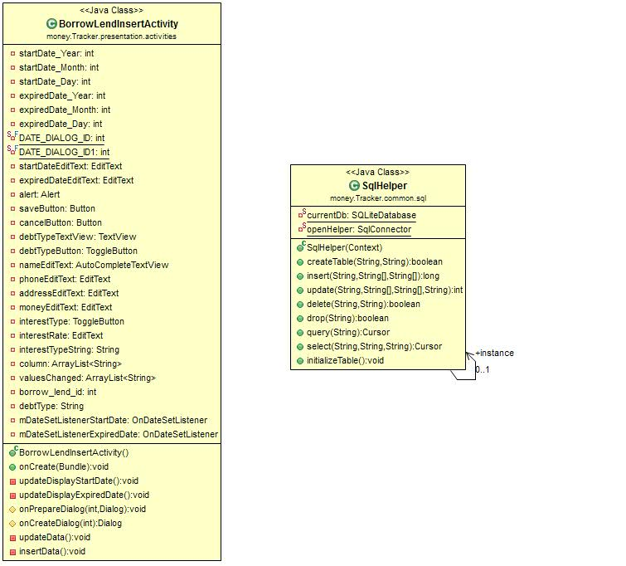

4.2.3.2. View a record

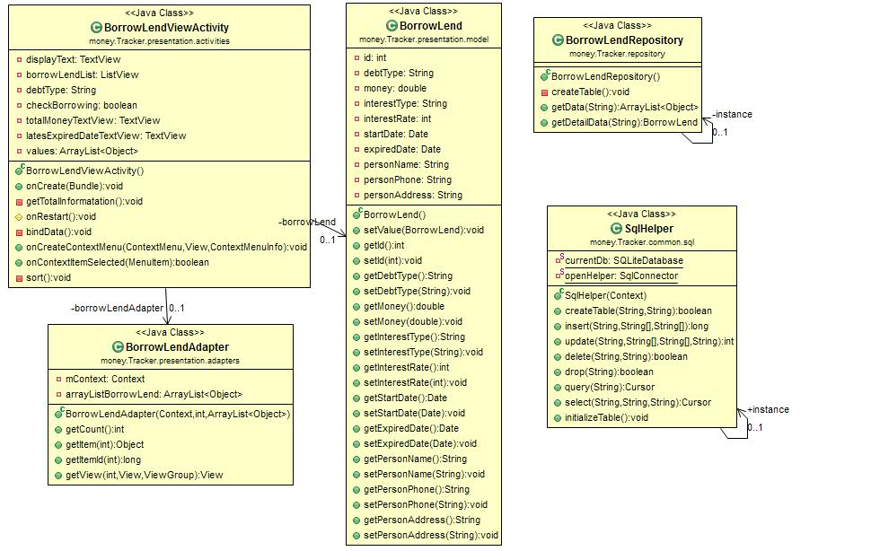

### **4.2.4. Report**

4.2.4.1. Report View

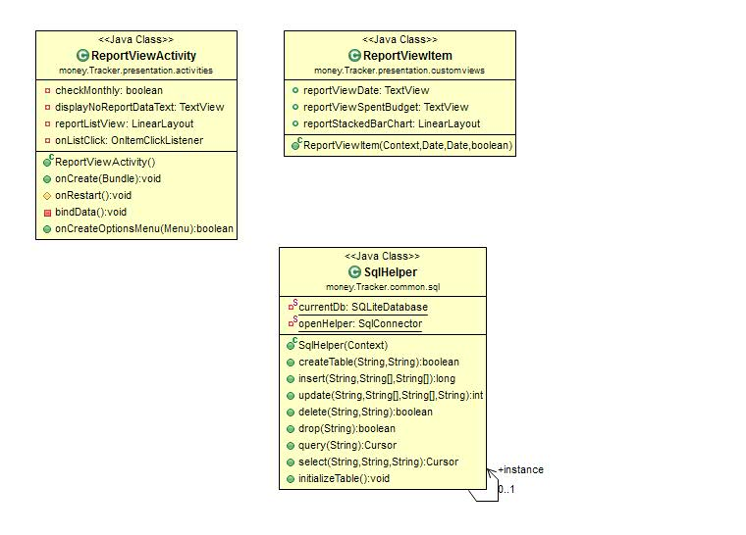

# Sequence Diagram

## Incomes & Expenses management function

### **Add a record**

### **Edit a record**

### **View a record**

### **View a detail record**

**5.1.5. Delete a record**

## Schedule function

### **Add a record**

### **Edit a record**

### **View a record**

### **View a detail record**

**5.2.5. Delete a record**

## Borrowing & Lending management function

* + 1. **Add a record**

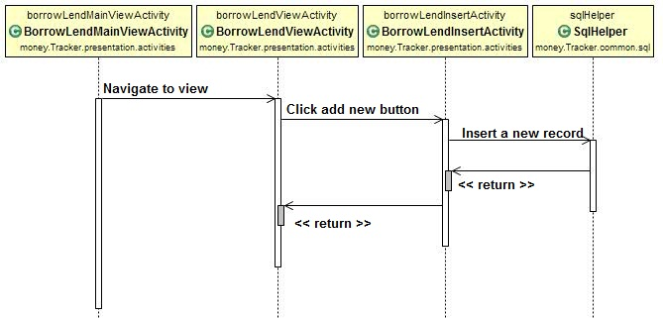

* + 1. **Edit a record**

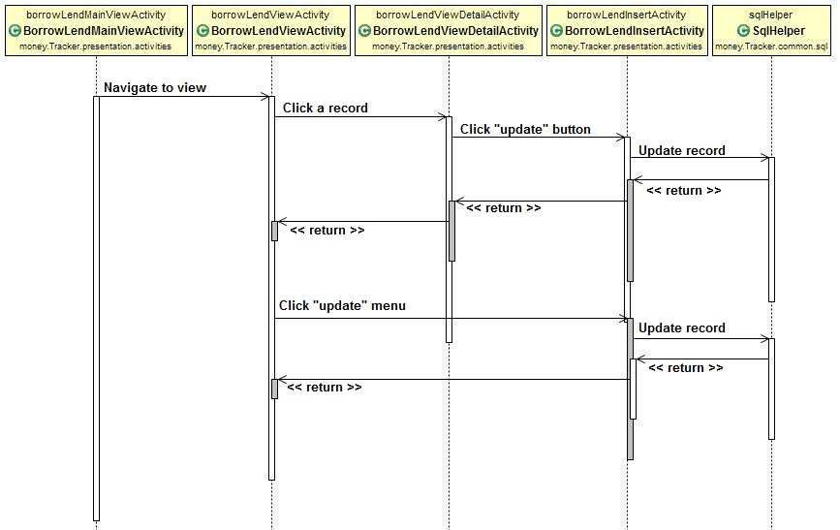

* + 1. **View a record**

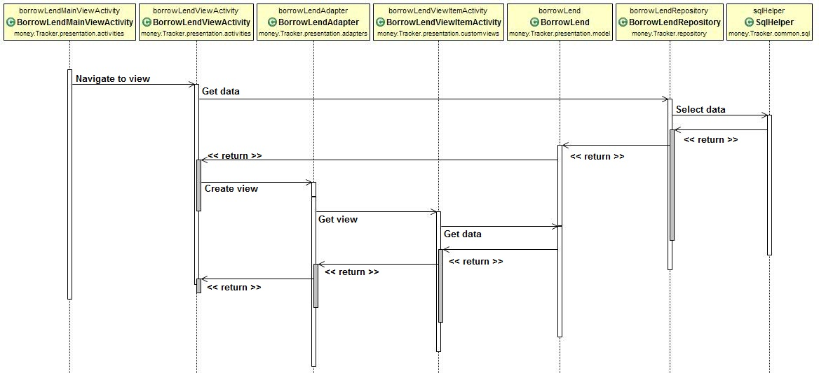

* + 1. **View a detail record**

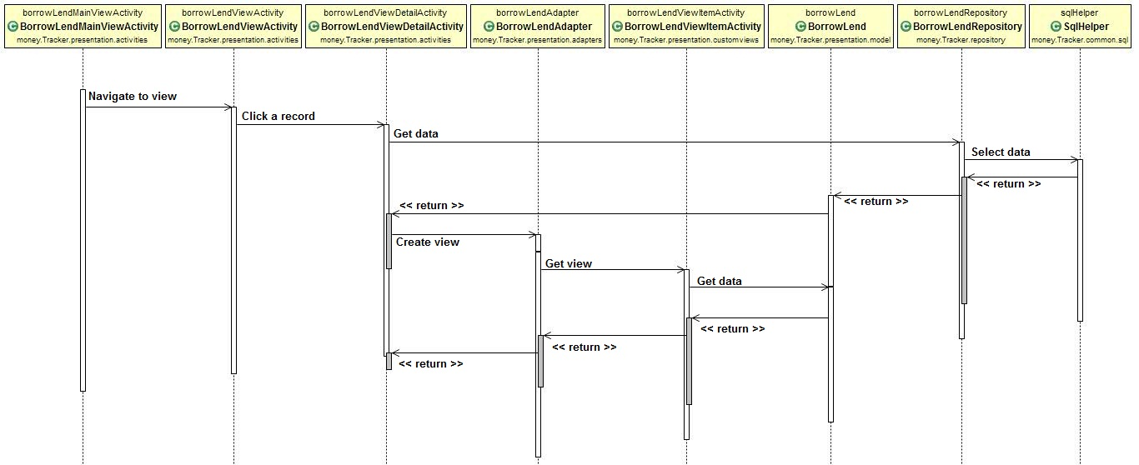

**5.3.5. Delete a record**

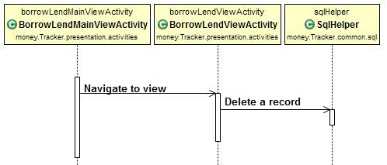

## Report function

* + 1. **View a record**

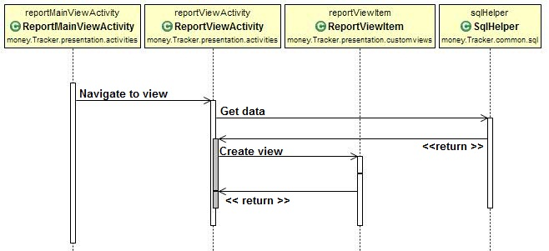

* + 1. **View detail a record**

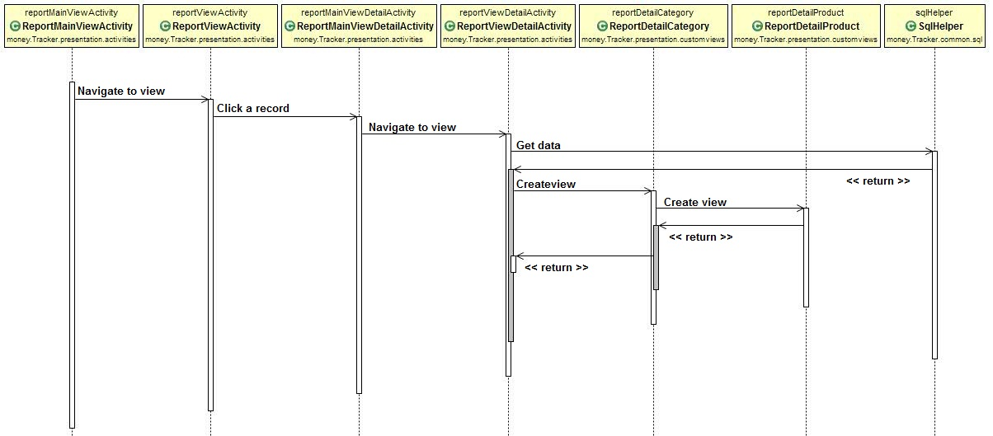

* + 1. **View chart**

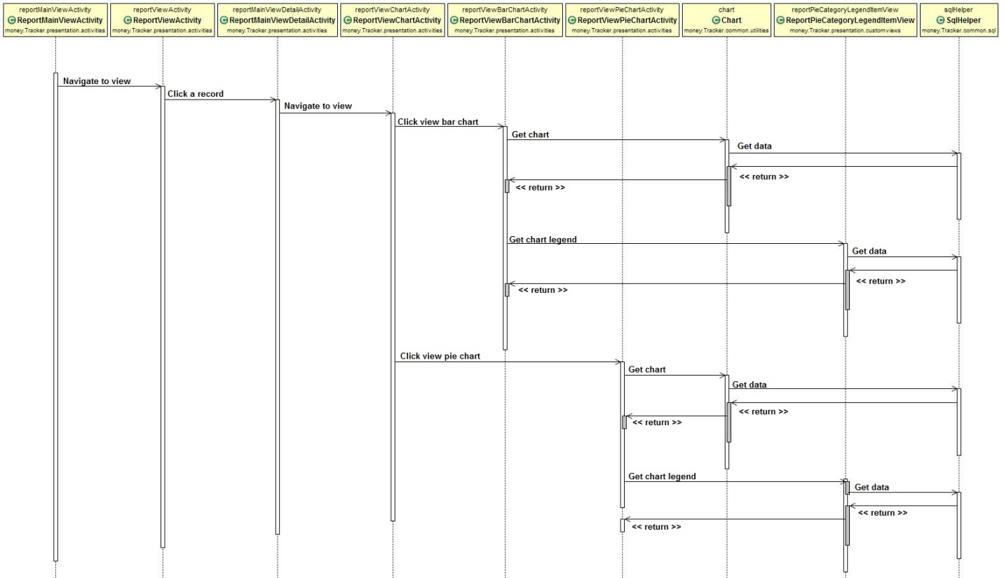

# User Interface Design

# Database Design

* 1. Database Server Design
     1. Database Diagram

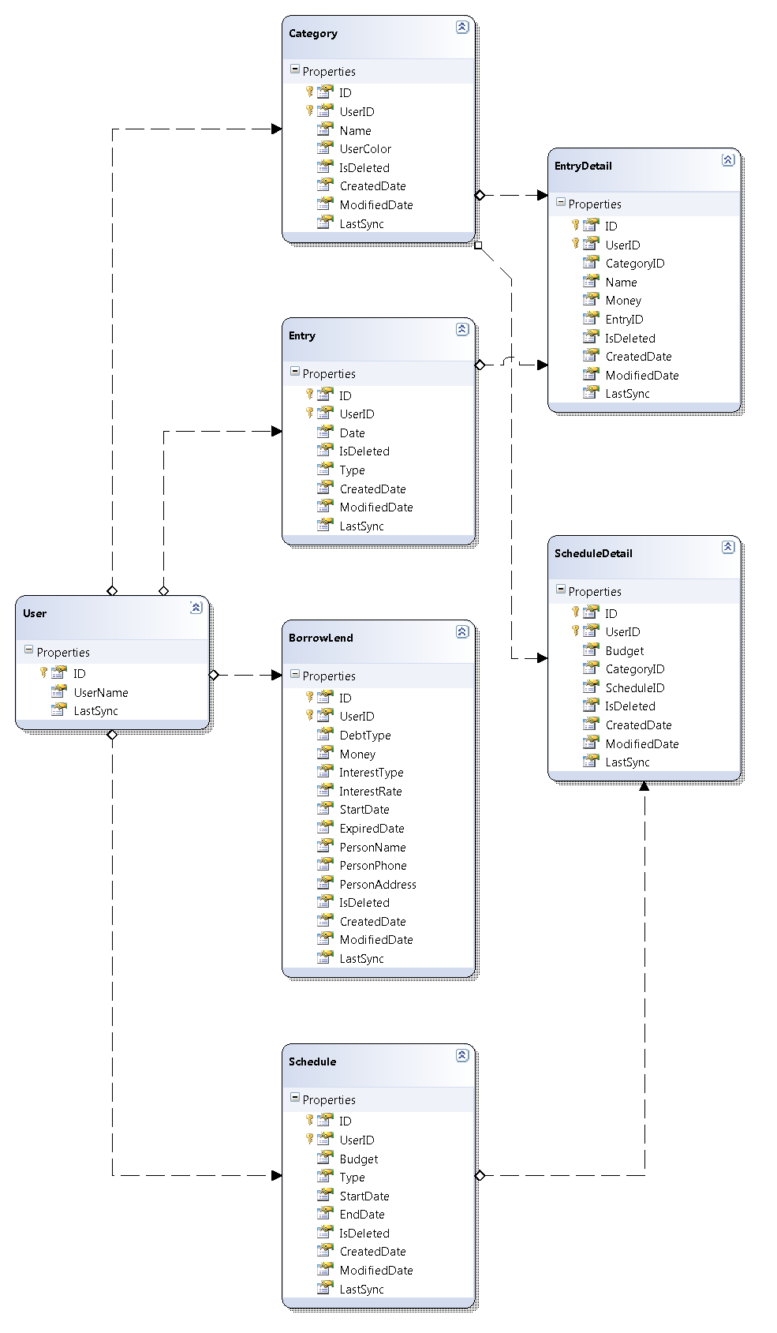

* + 1. Tables

|  |  |
| --- | --- |
| **Table Name** | **Description** |
| User | Stores information of user |
| Category | Stores all category |
| Entry | Stores all entry |
| EntryDetail | Stores detail for each entry |
| Schedule | Stores all schedule |
| ScheduleDetail | Stores detail for each schedule |
| BorrowLend | Stores all borrowing and lending |

* + 1. Table Description
       1. User

|  |  |  |  |  |
| --- | --- | --- | --- | --- |
| **Column Name** | **Type** | **Allow Nulls** | **P/F Key** | **Description** |
| ID | INT |  | PK | User ID |
| UserName | VARCHAR(100) |  |  | Account username |
| LastSync | DATETIME |  |  | The latest date time which user synchronize |

* + - 1. Category

|  |  |  |  |  |
| --- | --- | --- | --- | --- |
| **Column Name** | **Type** | **Allow Nulls** | **P/F Key** | **Description** |
| ID | BIGINT |  | PK | Category ID |
| UserID | INT |  | PK, FK | User ID |
| Name | NVARCHAR(100) |  |  | Category Name |
| UserColor | NVARCHAR(100) |  |  | Category Color |
| IsDeleted | INT |  |  | Mark a record is deleted or not |
| CreatedDate | DATETIME |  |  | The creation date time of a record |
| ModifiedDate | DATETIME |  |  | The updated data’s date time of a record |
| LastSync | DATETIME |  |  | The latest date time of record which user synchronized |

* + - 1. Entry

|  |  |  |  |  |
| --- | --- | --- | --- | --- |
| **Column Name** | **Type** | **Allow Nulls** | **P/F Key** | **Description** |
| ID | BIGINT |  | PK | Entry ID |
| UserID | INT |  | PK, FK | User ID |
| Date | DATETIME |  |  | Entry Name |
| Type | NVARCHAR(100) |  |  | Entry Type (Income/ Expense) |
| IsDeleted | INT |  |  | Mark a record is deleted or not |
| CreatedDate | DATETIME |  |  | The creation date time of a record |
| ModifiedDate | DATETIME |  |  | The updated data’s date time of a record |
| LastSync | DATETIME |  |  | The latest date time of record which user synchronized |

* + - 1. EntryDetail

|  |  |  |  |  |
| --- | --- | --- | --- | --- |
| **Column Name** | **Type** | **Allow Nulls** | **P/F Key** | **Description** |
| ID | BIGINT |  | PK | Entry Detail ID |
| UserID | INT |  | PK, FK | User ID |
| CategoryID | BIGINT |  | FK | Category ID |
| EntryID | BIGINT |  | FK | Entry ID |
| Name | NVARCHAR(100) |  |  | Entry Detail Name |
| Money | FLOAT |  |  | The money of entry detail |
| IsDeleted | INT |  |  | Mark a record is deleted or not |
| CreatedDate | DATETIME |  |  | The creation date time of a record |
| ModifiedDate | DATETIME |  |  | The updated data’s date time of a record |
| LastSync | DATETIME |  |  | The latest date time of record which user synchronized |

* + - 1. Schedule

|  |  |  |  |  |
| --- | --- | --- | --- | --- |
| **Column Name** | **Type** | **Allow Nulls** | **P/F Key** | **Description** |
| ID | BIGINT |  | PK | Schedule ID |
| UserID | INT |  | PK, FK | User ID |
| Budget | FLOAT |  |  | The total budget of schedule |
| Type | INT |  |  | The type of schedule (Month/Week) |
| StartDate | DATETIME |  |  | The start of schedule’s period |
| EndDate | DATETIME |  |  | The end of schedule’s period |
| IsDeleted | INT |  |  | Mark a record is deleted or not |
| CreatedDate | DATETIME |  |  | The creation date time of a record |
| ModifiedDate | DATETIME |  |  | The updated data’s date time of a record |
| LastSync | DATETIME |  |  | The latest date time of record which user synchronized |

* + - 1. ScheduleDetail

|  |  |  |  |  |
| --- | --- | --- | --- | --- |
| **Column Name** | **Type** | **Allow Nulls** | **P/F Key** | **Description** |
| ID | BIGINT |  | PK | Schedule Detail ID |
| UserID | INT |  | PK, FK | User ID |
| CategoryID | BIGINT |  | FK | Category ID |
| ScheduleID | BIGINT |  | FK | Schedule ID |
| Budget | FLOAT |  |  | The budget for each category |
| IsDeleted | INT |  |  | Mark a record is deleted or not |
| CreatedDate | DATETIME |  |  | The creation date time of a record |
| ModifiedDate | DATETIME |  |  | The updated data’s date time of a record |
| LastSync | DATETIME |  |  | The latest date time of record which user synchronized |

* + - 1. BorrowLend

|  |  |  |  |  |
| --- | --- | --- | --- | --- |
| **Column Name** | **Type** | **Allow Nulls** | **P/F Key** | **Description** |
| ID | BIGINT |  | PK | Schedule Detail ID |
| UserID | INT |  | PK, FK | User ID |
| DebtType | NVARCHAR(100) |  |  | The type of debt (borrowing/ lending) |
| Money | FLOAT |  |  | The total money of debt |
| InterestType | NVARCHAR(100) |  |  | The type of interest (simple/ compound) |
| InterestRate | INT | X |  | The rate of interest |
| StartDate | DATETIME |  |  | Starting date time of debt period |
| ExpiredDate | DATETIME | X |  | Expired date time of debt period |
| PersonName | NVARCHAR(100) |  |  | The owner’s name of debt |
| PersonPhone | NVARCHAR(100) | X |  | The owner’s phone of debt |
| PersonAddress | NVARCHAR(100) | X |  | The owner’s address of debt |
| IsDeleted | INT |  |  | Mark a record is deleted or not |
| CreatedDate | DATETIME |  |  | The creation date time of a record |
| ModifiedDate | DATETIME |  |  | The updated data’s date time of a record |
| LastSync | DATETIME |  |  | The latest date time of record which user synchronized |

* 1. Database Client Design
     1. Database Diagram

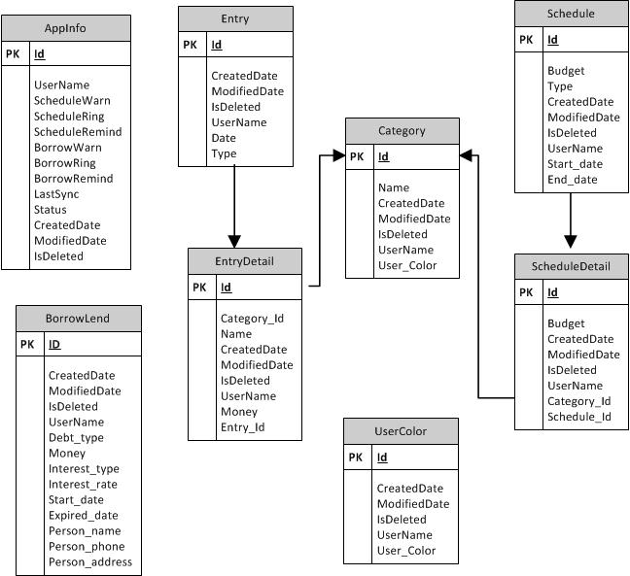

* + 1. Tables

|  |  |
| --- | --- |
| **Table Name** | **Description** |
| AppInfo | Stores information of application |
| Category | Stores all category |
| Entry | Stores all entry |
| EntryDetail | Stores detail for each entry |
| Schedule | Stores all schedule |
| ScheduleDetail | Stores detail for each schedule |
| BorrowLend | Stores all borrowing and lending |
| UserColor | Stores all color for category |

* + 1. Table Description
       1. AppInfo

|  |  |  |  |  |
| --- | --- | --- | --- | --- |
| **Column Name** | **Type** | **Allow Nulls** | **P/F Key** | **Description** |
| Id | LONG |  | PK | Application Information ID |
| UserName | TEXT |  |  | Account username |
| ScheduleWarn | INTEGER |  |  |  |
| ScheduleRing | TEXT |  |  |  |
| ScheduleRemind | LONG |  |  |  |
| BorrowWarn | INTEGER |  |  |  |
| BorrowRing | TEXT |  |  |  |
| BorrowRemind | LONG |  |  |  |
| LastSync | DATE |  |  | The latest date time of record which user synchronized |
| CreatedDate | DATE |  |  | The creation date time of a record |
| ModifiedDate | DATE |  |  | The updated data’s date time of a record |
| IsDeleted | INTEGER |  |  | Mark a record is deleted or not |

* + - 1. Category

|  |  |  |  |  |
| --- | --- | --- | --- | --- |
| **Column Name** | **Type** | **Allow Nulls** | **P/F Key** | **Description** |
| ID | Long |  | PK | Category ID |
| Name | TEXT |  |  | Category Name |
| CreatedDate | DATE |  |  | The creation date time of a record |
| ModifiedDate | DATE |  |  | The updated data’s date time of a record |
| IsDeleted | INTEGER |  |  | Mark a record is deleted or not |
| UserName | TEXT |  |  | Account username |
| User_Color | TEXT |  |  | Category Color |

* + - 1. Entry

|  |  |  |  |  |
| --- | --- | --- | --- | --- |
| **Column Name** | **Type** | **Allow Nulls** | **P/F Key** | **Description** |
| Id | LONG |  | PK | Entry ID |
| CreatedDate | DATE |  |  | The creation date time of a record |
| ModifiedDate | DATE |  |  | The updated data’s date time of a record |
| IsDeleted | INTEGER |  |  | Mark a record is deleted or not |
| UserName | TEXT |  |  | Account username |
| Date | DATE |  |  | Entry Name |
| Type | INTEGER |  |  | Entry Type(1: Income/ 0: Expense) |

* + - 1. EntryDetail

|  |  |  |  |  |
| --- | --- | --- | --- | --- |
| **Column Name** | **Type** | **Allow Nulls** | **P/F Key** | **Description** |
| Id | LONG |  | PK | Entry Detail ID |
| Category_Id | LONG |  | FK | Category ID |
| Name | TEXT |  |  | Entry Detail Name |
| CreatedDate | DATE |  |  | The creation date time of a record |
| ModifiedDate | DATE |  |  | The updated data’s date time of a record |
| IsDeleted | INTEGER |  |  | Mark a record is deleted or not |
| UserName | TEXT |  |  | Account username |
| Entry_Id | LONG |  | FK | Entry ID |
| Money | LONG |  |  | The money of entry detail |

* + - 1. Schedule

|  |  |  |  |  |
| --- | --- | --- | --- | --- |
| **Column Name** | **Type** | **Allow Nulls** | **P/F Key** | **Description** |
| Id | LONG |  | PK | Schedule ID |
| Budget | LONG |  |  | The total budget of schedule |
| Type | INTEGER |  |  | The type of schedule (1: Month/0: Week) |
| CreatedDate | DATE |  |  | The creation date time of a record |
| ModifiedDate | DATE |  |  | The updated data’s date time of a record |
| IsDeleted | INTEGER |  |  | Mark a record is deleted or not |
| UserName | TEXT |  |  | Account username |
| Start_date | DATE |  |  | The start of schedule’s period |
| End_date | DATE |  |  | The end of schedule’s period |

* + - 1. ScheduleDetail

|  |  |  |  |  |
| --- | --- | --- | --- | --- |
| **Column Name** | **Type** | **Allow Nulls** | **P/F Key** | **Description** |
| Id | LONG |  | PK | Schedule Detail ID |
| Budget | LONG |  |  | The budget for each category |
| CreatedDate | DATE |  |  | The creation date time of a record |
| ModifiedDate | DATE |  |  | The updated data’s date time of a record |
| IsDeleted | INTEGER |  |  | Mark a record is deleted or not |
| UserName | TEXT |  |  | Account username |
| Category_Id | LONG |  | FK | Category ID |
| Schedule_Id | LONG |  | FK | Schedule ID |

* + - 1. BorrowLend

|  |  |  |  |  |
| --- | --- | --- | --- | --- |
| **Column Name** | **Type** | **Allow Nulls** | **P/F Key** | **Description** |
| Id | LONG |  | PK | Schedule Detail ID |
| CreatedDate | DATE |  |  | The creation date time of a record |
| ModifiedDate | DATE |  |  | The updated data’s date time of a record |
| IsDeleted | INTEGER |  |  | Mark a record is deleted or not |
| UserName | TEXT |  |  | Account username |
| Debt_type | TEXT |  |  | The type of debt (borrowing/ lending) |
| Money | LONG |  |  | The total money of debt |
| Interest_type | TEXT |  |  | The type of interest (simple/ compound) |
| Interest_rate | INTEGER | X |  | The rate of interest |
| Start_date | DATE |  |  | Starting date time of debt period |
| Expired_date | DATE | X |  | Expired date time of debt period |
| Person_name | TEXT |  |  | The owner’s name of debt |
| Person_phone | TEXT | X |  | The owner’s phone of debt |
| Person_address | TEXT | X |  | The owner’s address of debt |

7.2.3.8: UserColor

|  |  |  |  |  |
| --- | --- | --- | --- | --- |
| **Column Name** | **Type** | **Allow Nulls** | **P/F Key** | **Description** |
| ID | Long |  | PK | Color ID |
| CreatedDate | DATE |  |  | The creation date time of a record |
| ModifiedDate | DATE |  |  | The updated data’s date time of a record |
| IsDeleted | INTEGER |  |  | Mark a record is deleted or not |
| UserName | TEXT |  |  | Account username |
| User_Color | TEXT |  |  | Color code |